
Nitin Suresh Chopra

Principal Consultant - Mumbai

Github Copilot Certified Microsoft Certified Azure Fundamentals
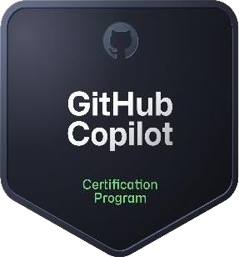
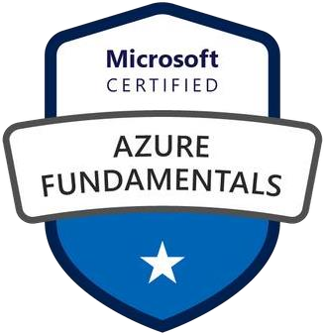



Snowflake SnowPro Core Certified
Snowflake Advanced: Architect

©confidential 1

Public

Experienced Data and Cloud specialist with 22+ years in Enterprise Systems, providing expertise in strategic, leadership and client management responsibilities.

Seeking to drive impactful transformation through hands-on delivery in a leadership capacity. Currently focused on Snowflake Architecture and Snowflake Admin role.

Areas of Expertise
- Snowflake Admin/Architect
- Snowsight
- DBT
- SQL
- SAP BI/BW
- Native Hana
- Datawarehouse

Profile Summary:

Skills
- Team Leadership & Mentorship
- Client Management & Strategy
- Collaboration
- Innovation
- Project Execution
- Operational Excellence
- Decision Making
- Analytical & Problem Solving

Education
- Mumbai University, Mumbai
Bachelor of Commerce, B-Com· (1995 - 1998)

Current Organization
- Wipro Technologies

Key Roles:

Domains/Verticals
- Retail
- Banking

- Acted as a trusted advisor to clients providing high-level insights and solutions.
- Analyse complex business problems and recommend strategies for growth, efficiency and transformation.
- Snowflake Admin (3+ years): Managed user/role admin, data masking policies, Snowpipe automation, warehouse optimization, and Snowsight dashboards for leadership reporting.
- Snowflake Architect (3+ years): Led cloud migration projects using Snowflake along with Streams/Task and DBT. Handled end-to-end delivery, team
guidance, and system architecture in a structured and scalable way.
- Built a proof-of-concept(POC) using Snowflake Cortex AI LLM functions (SENTIMENT, SUMMARIZE, COMPLETE) to automate customer feedback analysis
— including sentiment classification, summarization, and issue categorization — eliminating manual review processes.

Key Achievements
- Brought over 15+ years of diverse experience across enterprise data platforms and business analytics, including SAP BI/BW and Native HANA. Demonstrated leadership in solution delivery, stakeholder engagement, and performance-focused analytics—laying a strong foundation for current cloud architecture roles.
- Drove global B2B sales of computer memory modules, managing international client relations via online and in-person channels, and strengthening
solution-driven communication skills.
- Oversaw large-scale projects , ensuring projects are delivered on time, within budget, quality and client expectations.
- Managed cross-functional teams (consultants, analysts, specialists) to ensure alignment and goals.
- Optimize consulting methodologies, tools, and frameworks.
Mobile: 9920936649
Email: nickyu911@gmail.com
- Managing Data Platforms (Snowflake)
- Leading Data Architecture / Administrator Initiatives
- Driving Data Operations Excellence
- Data Security and Compliance Leadership
- Managing Data Engineering Teams
- Team Leadership and Collaboration

Certifications:
- GitHub Copilot Certified
- SnowPro Core Certified
- SnowPro Advanced: Architect
- Azure Certified expert

Mobile: 9920936649
Email: nickyu911@gmail.com
Organization | Client | Technology | Role | Start Date | End Date
Wipro LTD | - Northern Trust  - TD Bank | Snowflake Architect/Admin | Responsible for designing and implementing scalable, high-performance data solutions using the Snowflake platform. I led the end-to-end architecture for data pipelines, encompassing everything from data ingestion to transformation and reporting. | Sep-25 Jan-23 | April-26 Aug-25
 | Freedom Mortgage | Snowflake Admin | Responsible for managing access and security, monitoring and optimizing system performance, overseeing data loading along with data masking, and ensuring robust backup, cloning, and data recovery procedures. Played a key role in maintaining security and  compliance standards. | Apr-20 | Jan-23
IDC Technologies Pvt Ltd | Colgate Palmolive India Ltd | Native Hana | My responsibilities included working on Native Hana and applying previous relevant experience. This included creating HANA objects as well as data modeling, performance tuning, and integrating with both SAP and non-SAP systems. | Jul-19 | Apr-20
L&T Infotech (LTI) | MRC Global Ltd | Native Hana | Focused on designing, developing, and implementing solutions using SAP's advanced in-memory database platform, | Jan-19 | May-19
 | Colgate Palmolive India Ltd | Native Hana | My role involved designing, developing, and implementing solutions using SAP's in-memory database platform. | May-17 | Dec-18

Mobile: 9920936649
Email: nickyu911@gmail.com
Organization | Client | Technology | Role | Start Date | End Date
Mahindra and Mahindra SAP BI/BW Led the transition from the legacy SAP BW system to SAP Apr-16 May-17
Altimetrik India Pvt Ltd BW/4HANA.
LafargeHolcim Asia Pacific SAP BI/BW Provided support & assistance for their SAP BI/BW Mar-15 Mar-16
platform.
Olam Information Services Pvt Ltd | Olam Information Services Pvt Ltd SAP BI/BW |  | Provided global support for SAP BI/BW, ensuring 24/7 assistance by working in various shifts. This role allowed me to gain valuable experience in managing and resolving complex issues in a dynamic and fast-paced environment. | Feb-14 | Mar-15
RSS Pvt Ltd (Tandon Group) | Sales |  | Provided technical support and sold these products online to our targeted customer base in Europe and the Asia-Pacific region. | Jan-06 | Nov-09
SITEL India Ltd | AOL (American Online) | Technical Support & Sales | Responsible for troubleshooting technical issues.  I actively promoted and sold new versions of AOL's broadband services attributing to customer satisfaction while contributing to the company's sales goals. | Jan-02 | Dec-05
Jaytech Ltd | Gateway Computers | Technical Support | Provided technical support for Gateway computers, assisting customers with any issues, ensuring that customers received the help they needed to resolve their computer-related concerns. | Jul-00 | Sep-01

